

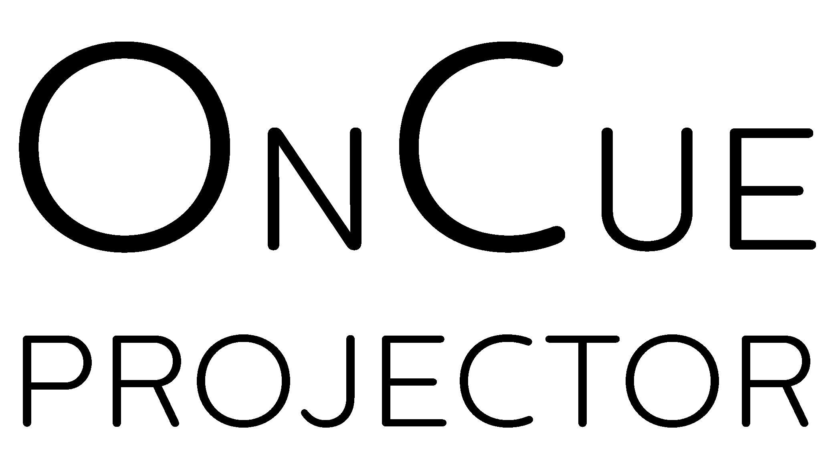

Technical Manual

GPL

VideoLAN, VLC, VLC media player and x264 are trademarks owned by VideoLAN.

This program uses third party libraries

libVLC  
pyQt

// HgSharp

//

// Copyright 2005-2012 Matt Mackall <mpm@selenic.com> and Mercurial contributors

// Copyright 2011-2012 Anton Gogolev <anton.gogolev@hglabhq.com>

//

// The following code is a derivative work of the code from the Mercurial project,

// which is licensed GPLv2. This code therefore is also licensed under the terms

// of the GNU Public License, verison 2.